Dr. Cheryl L Brown, Director  Jacksonville City Council  904.630.1452  CLBrown@coj.net | 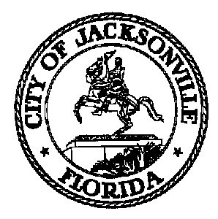 | 117 West Duval Street, Suite 425  Jacksonville, Florida 32202
SAFETY AND CRIME REDUCTION COMMISSION

Meeting Notice

October 25, 2019
5:00 p.m.

TO: Safety and Crime Reduction Commission Members

Sam Newby, Vice Chair | Ellen Glasser
Matt Carlucci | Shelley Grant
Camille Burban | Constance Hall
Josh Cockrell | Linda Joseph
Larry Cook | Ronnie King
Richard Danford | Timothy Sloan
Joe Peppers | Vicki Waytowich
Frank Denton | Shamika Baker Wright
Sabrina Edwards
Tom Geismar
Brandon Griggs
William (W.C.) Gentry

FROM: Mark Griffin, Chair

SUBJECT: Safety and Crime Reduction Commission Organizational Meeting Notice 10.29.19

Notice is hereby given that the Safety and Crime Reduction Commission Organizational Meeting will be held on Tuesday, October 29, 2019 at 9:00 A.M. The meeting will be held in the Council Chambers located at 117 W. Duval St., 1st Floor, City Hall - St. James Building.

When attending Safety and Crime Reduction Commission Meetings, members are asked to park in the parking garage located on the corner of Main and Duval Street (Library Garage) to receive free parking. Please see Staff at each meeting for parking validation.

cc: Cheryl Brown, Council Director File
Carol Owens cityc@coj.net
Jeff Clements, Chief of Research

